

Python Practical’s

# TASK 2

Smit Joshi | 06-08-2023

# Practical 1

1. Write a python program to find whether the given number is perfect or not .

sum=0

for i in range(1,number):

    if number%i==0:

        sum+=i

if sum==number:

    print(f"{number} is perfact number")

else:

    print(f"{number} is not perfact number")

### Output:

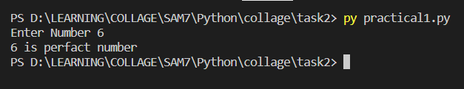

# Practical 2

Write a python program to find the given number is palindrome or not .

number=int(input("Enter The number "))

num2=number

reverse=""

while num2 > 0:

    digit=str(int(num2%10))

    reverse+=digit

    num2//=10

if reverse==str(number):

    print(f"{number} is Pellindrom number")

else:

    print(f"{reverse} is not a Pellindrom number")

### Output:

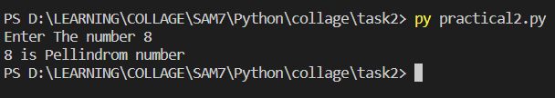

# Practical 3

Write a python program to display the following pattern

*

* *

* * *

* * * *

* * * * *

n=int(input("Enter Number: "))

for i in range(1,n+1):

    for j in range(i):

        print("*",end="")

    print()

### Output:

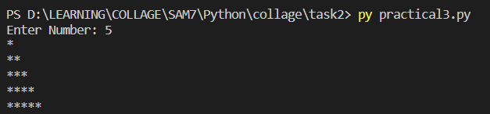

# Practical 4

Write a python program to take two numbers from user and apply inbuilt function to find absolute of no, ceil of NUMBER, floor, max, min, power, sqrt, round off the two numbers.

import math

num1=int(input("Enter Number 1 "))

num2=int(input("Enter Number 2 "))

# Applying functions

print(f"Absolute of {num1}/{num2}:",abs(num1/num2))

print(f"Ceil of : {num1}/{num2}:",math.ceil(num1/num2))

print(f"floor of : {num1}/{num2}:",math.floor(num1/num2))

print(f"Max between : {num1} and {num2}:",max(num1,num2))

print(f"Min between : {num1} and {num2}:",min(num1,num2))

print(f"power of : {num1} is {pow(num1,2)} and {num2} is {pow(num2,2)}")

print(f"sqrt of: {num1} is {math.sqrt(num1)} and {num2} is {math.sqrt(num2)}")

print(f"Round off Of {num1}/{num2} is {round(num1/num2,2)}")

### Output:

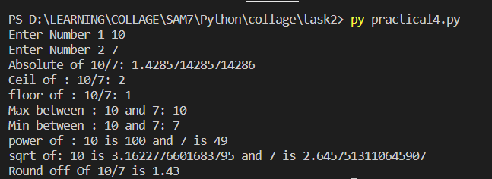

# Practical 5

## Write a python program to generate 20 numbers randomly in between 41 to 75.

import random

for i in range(41,76):

    print(random.randrange(41,76),end=" ")

### Output:



# Practical 6

Write a python program to find input string is ALPHABET, NUMERIC and

alphanumeric or is space.

testString=input("Enter Something... ")

print(f"{testString} is Alphabet: {testString.isalpha()}")

print(f"{testString} is Numeric: {testString.isnumeric()}")

print(f"{testString} is Alpha Numeric: {testString.isalnum()}")

print(f"{testString} is Space: {testString.isspace()}")

### Output:

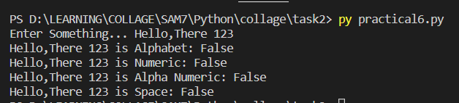

# Practical 7

Write a python program to implements function on the string

- capitalize - center - count - find - lower

- upper - replace - split - swap-case

testString=input("Enter String: ")

print(f"Capitalize: {testString.capitalize()}")

print(f"Center: {testString.center(50)}")

print(f"count: {testString.count('s')}")

print(f"find: {testString.find('s')}")

print(f"lower: {testString.lower()}")

print(f"upper: {testString.upper()}")

print(f"replace: {testString.replace('M','S')}")

print(f"split: {testString.split(' ')}")

print(f"swap-case: {testString.swapcase()}")

### Output:

